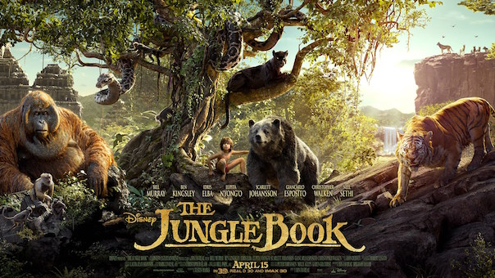

Task 3
Now that you have a good understanding of Mowgli’s life in the jungle and you have considered what you would like to say to your parents, you are now going to compose your letter.
Genre Checklist
Sender’s address
Date
An appropriate greeting
Introduction
Paragraphs around a theme
1st person
Informal vocabulary
A conclusion
Sender’s name

Here is an example of how you could start this letter:
To Mum and Dad,
I have longed to write this letter for a number of years now, but I have never found the courage to do so… until now. Oh how I miss you so very dearly! Most importantly, I want you to now that I am safe, happy and cared for. How are you and dad? I hope that you are well and that my disappearance hasn’t caused you prolonged pain. Although my heart aches from missing you, my life here is simply awesome. Let me tell you all about it.
Baloo. I introduce my one and only best friend in the entire universe. He’s crazy: he randomly breaks into song at any given moment; he dances without a care in the world; and he becomes my personal lilo when I fancy a relaxing float down the river. There was a huge parent-shaped hole in my heart when we were separated, however Baloo has certainly filled the majority of that gap.

