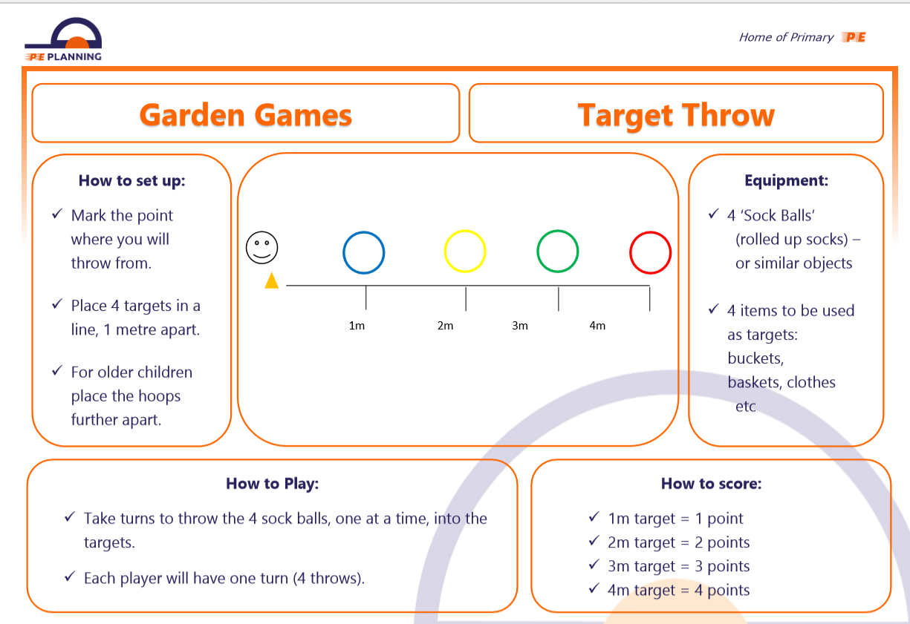
Use any balls that you have access to at home.
Have a competition in your family, who gets the most points?

