Non-Chronological Report: Hybrid Animal
Task 2
- Create a picture of your animal that incorporates characteristics from both of your chosen animals.
- This picture will be included on your non-chronological report so consider the size of your drawing.
- If you want to, you can create a picture of your animal’s habitat and the food that the animal eats to support your writing.

Task 3
- Write a non-chronological report on this newly discovered, genetically engineered hybrid animal
Objectives

Layout features – heading, sub-headings, bullet points, fact boxes, pictures
Subject specific vocabulary
Variety of sentence types: simple, compound and complex
Punctuation for parenthesis
( )
-
,
A range of sentence openers
Y5 GD & Y6
: and ; to mark independent clauses
Formality

An example
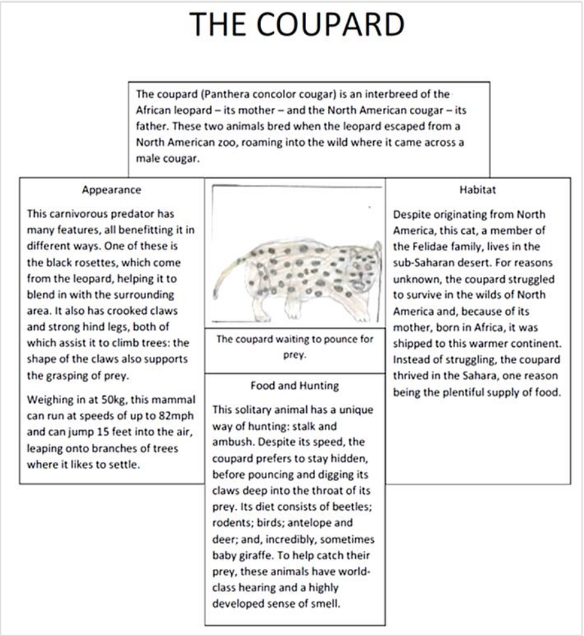

Task 4
- Decide how you would like to present your work. This could be done as a poster, power point, creative project, leaflet or on the computer.
- We look forward to seeing your completed piece!

