Non-Chronological Report: Hybrid Animal
A hybrid is the offspring of two animals of different species. Take a look at the examples below.
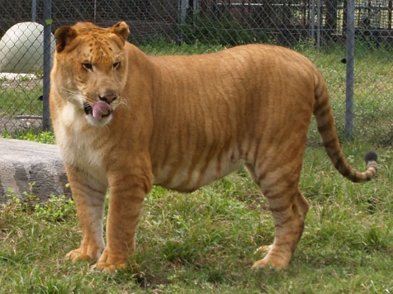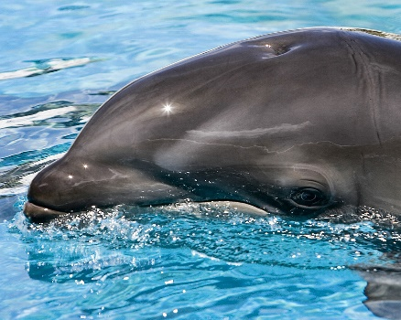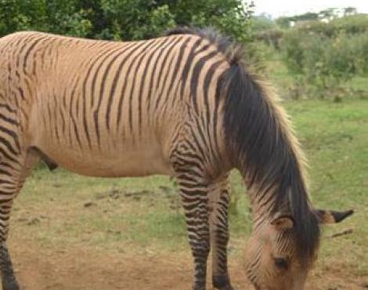
Liger (lion + tiger) Wholphin (whale + dolphin) Zorse (zebra + horse)

This week, we want you to create your own hybrid.
To do this you will need to:
- Research two animals that might have the potential to form a hybrid – they must come from the same animal group (i.e. mammals).
- Create a picture of your animal that incorporates characteristics from both of your chosen animals.
- Write a non-chronological report on this newly discovered, genetically engineered hybrid animal

Task 1
- Research two animals that might have the potential to form a hybrid – they must come from the same animal group (i.e. mammals).
 | Animal 1 - | Animal 2 - | Hybrid (merge the animals together)
Physical appearance
Habitat
Food & Hunting
Interesting Facts

