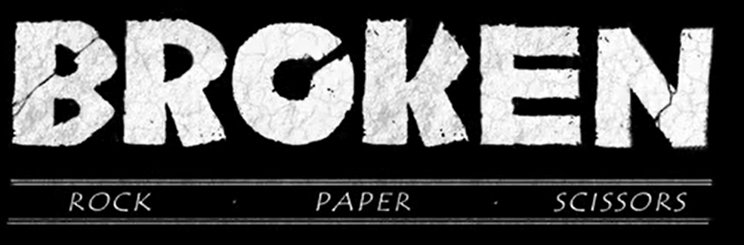
Before you watch the video, what do you think the film could be about from the title? About a vast rock which has an accident and has been broken.
Play a game of ‘rock, paper, scissors’ with a family member or friend. If this was a story who would win a battle? I played against my dad and won.

Task 1: Reading Comprehension
Play the film and pause it after 20 seconds.
- Which character do you think this is? I think it is rock
- Can you think of any adverbs to describe how he moves? Rock moves slowly and cautiously.
- Use similes or metaphors to describe his appearance. The Rock is as hard as a nails and as smooth as a babies bottom.

Pause the film after 52 seconds when Rock rests his head on his arm.
- Who is Rock watching? I think it is paper.
- Describe how Paper is moving. She is flying elegantly and slowly.
- What does Rock think about Paper? Amazed because paper has made a dead flower come back to life.

Pause after 1 minute
- How does the director use music and sound to signify danger? He goes from nice music to intense and scary which changes the atmosphere and affects how you feel.
- How could we get the same effect in our writing?
Use a simple sentence, and describe what he is doing which is chopping down trees and being unkind to nature, and use words that trigger emotions, such as angry, attacking and threatened.
Pause the film on the close up of Scissors’ face
- How could we describe Scissors’ face? Scissors looks scary because his face is pointy, and his eyes are like balls of fire.
- Use similes or metaphors to enhance the description of his angular features. His nose is as sharp as a knife and his chin is like a canal barge long and narrow.

Pause the film at 1 min 25 when Rock grips Paper’s arm.
- If he could speak what do you think he would say to her now? Come on we need to go now before he kills us !
- What punctuation would we need to use to write it down. Inverted commas, exclamation mark.
- Play the next couple of seconds and asks why can’t he hold on to Paper’s arm? Because when he touches her his hand starts to fall apart.

Pause the film at 2min 23 secs when Scissors is marching towards them.
- Based on the traditional game can children make predictions what will happen? Yes because scissors can’t cut rock so rock can protect paper.

Pause the film at 3 min 07 secs when Rock is stood over the lifeless Paper.
- How did Rock feel when he vanquished Scissors? Angry and sad about the fact scissors had killed paper.
- How does he feel now? Sad because paper was the only thing in rocks life, and that he has killed somebody.
- How might an author show this in their writing? Body language, facial expression, movement and actions.

Pause the film at 3 min 18 seconds. When Rock’s hands first crumble at her touch.
- What can Rock not do? Touch her.
- How will he help her? Maybe he will scream to wake her up .
- Will he help her? Yes.
- What would you do if you were Rock? I would carry her even though I would die.

Pause the film at 3 min 44 secs when the sun hits Paper’s face.
- What has happened? Rock has carried her to other flowers which is her natural habitat.

At the end of the film
- What has happened? The sun shone on paper and she came back to life.
- Were you right or wrong? I was wrong because Rock didn’t fall down a hill.
- Do you think Rock regrets his actions? Yes because he has killed someone and no because he has saved someone’s life.
- How does Paper feel about Rock? Amazed about the fact that Rock has sacrificed himself to save herself.

