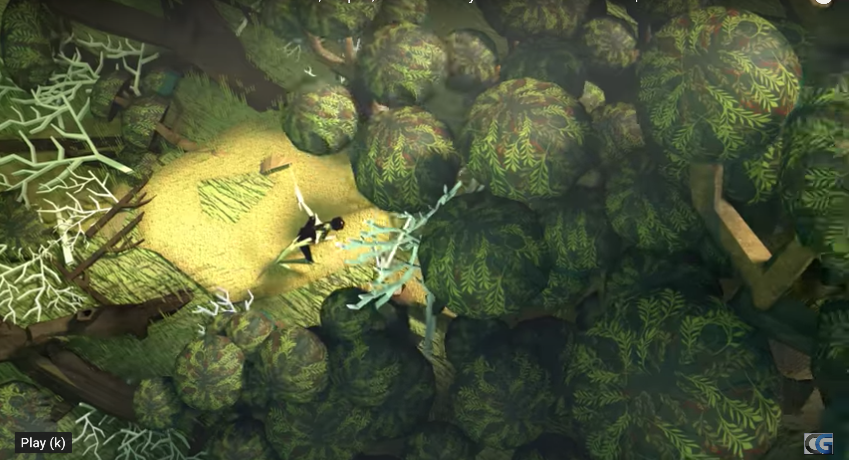

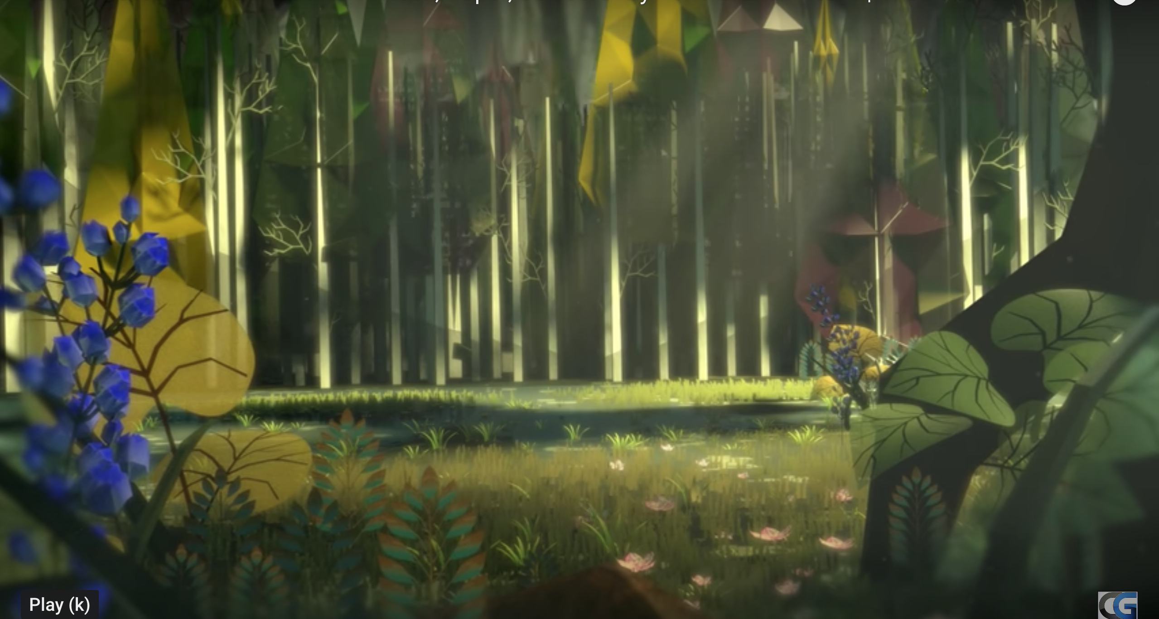

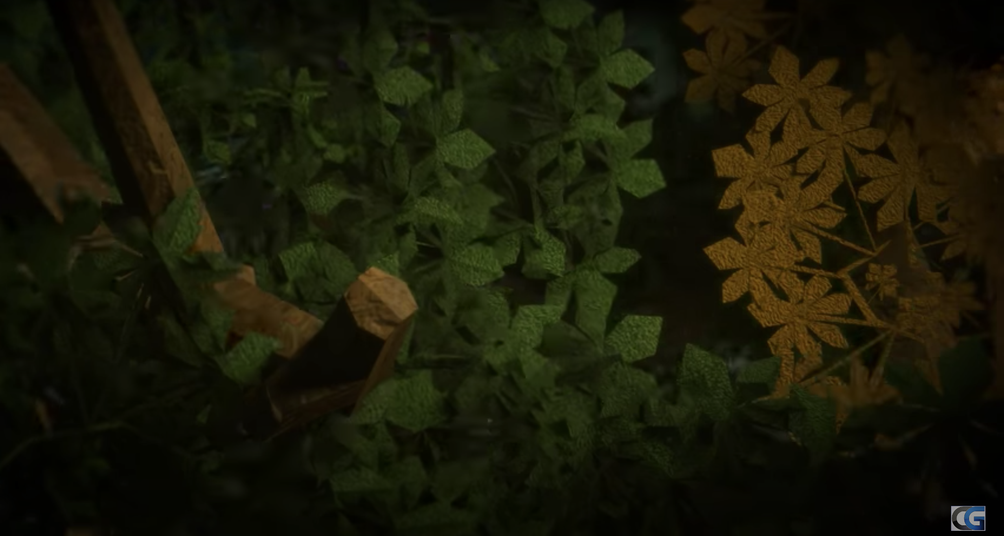

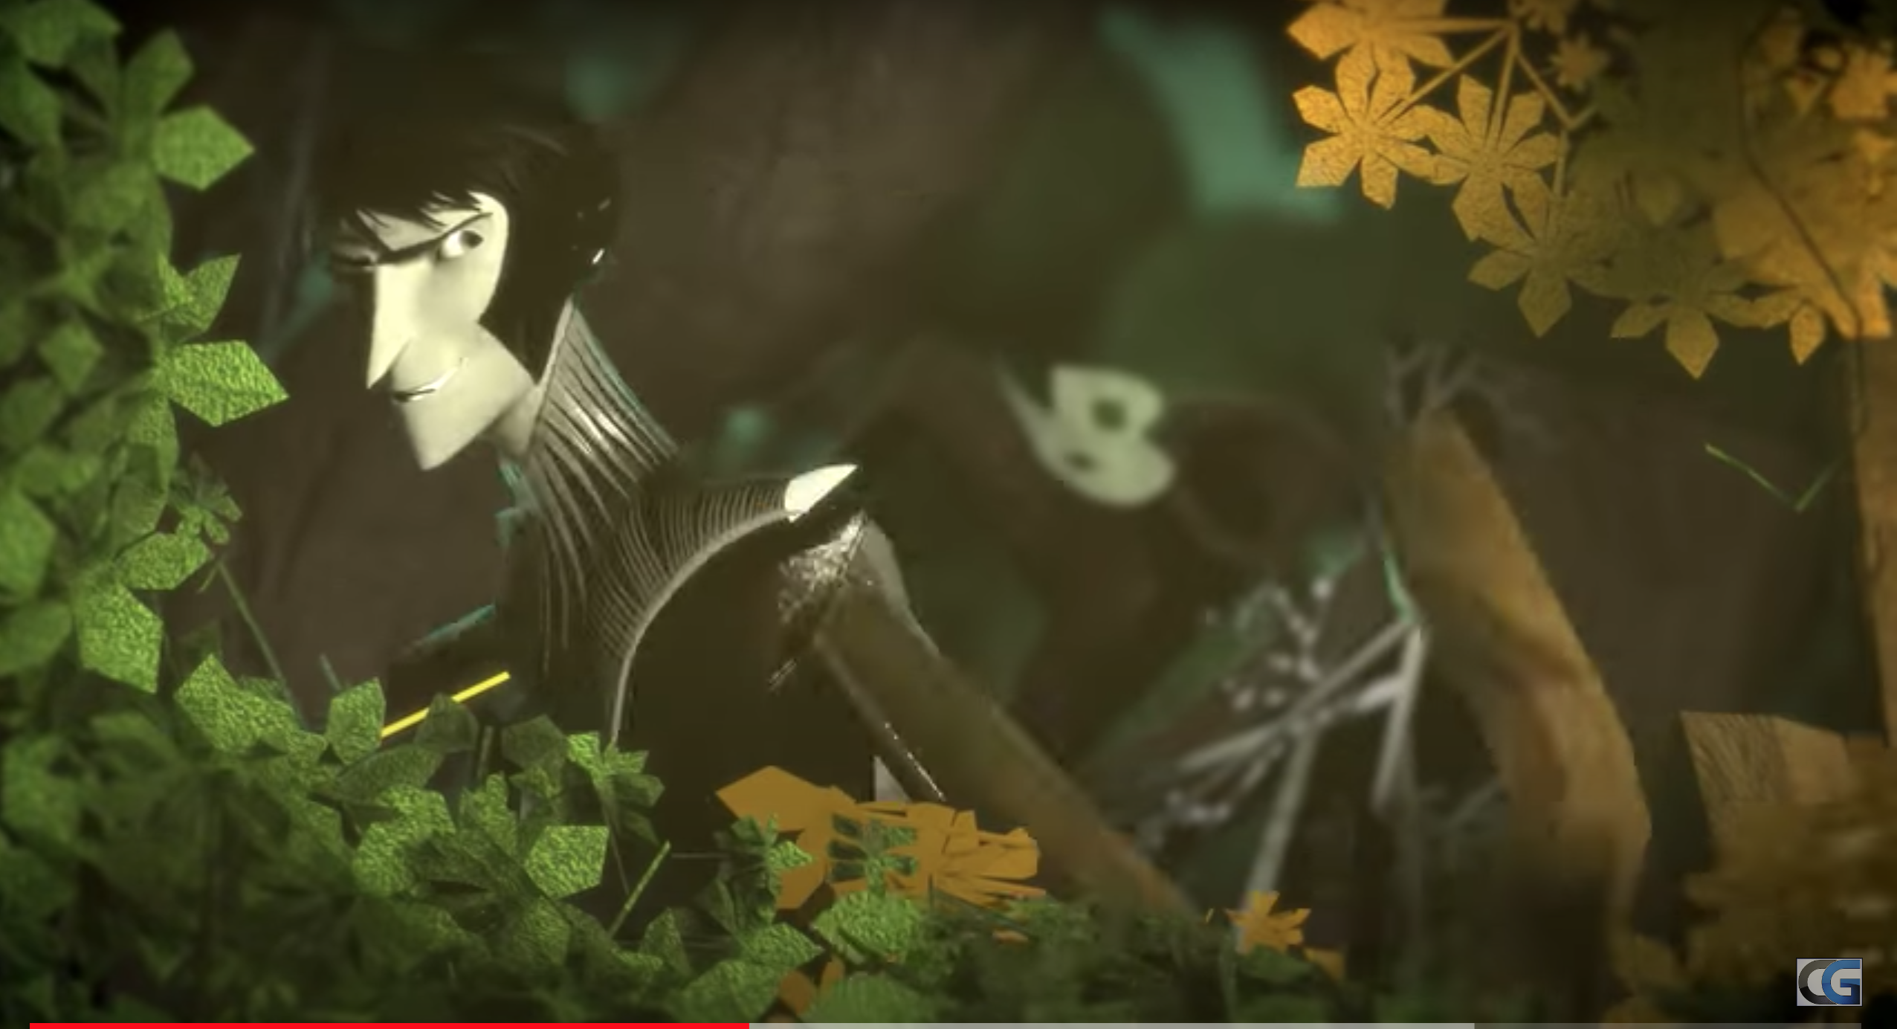

Looking down through the dark, bushy trees was scissors chopping down everything in his sight. Scissors was going for paper trying to kill her. As he got deeper into the forest it got darker and darker chopping everything in his sight to kill paper. Scraping the floor as he edged forward nearer to paper. They came to a dead end suddenly one of papers hairs fell of her head, scissors cached it and held it for a second and then clipped it in half. He edged closer and closer until paper fled at him and scissors killed her. Rock wasn’t happy with it so he jumped into the air and crushed scissors and he was dead.


