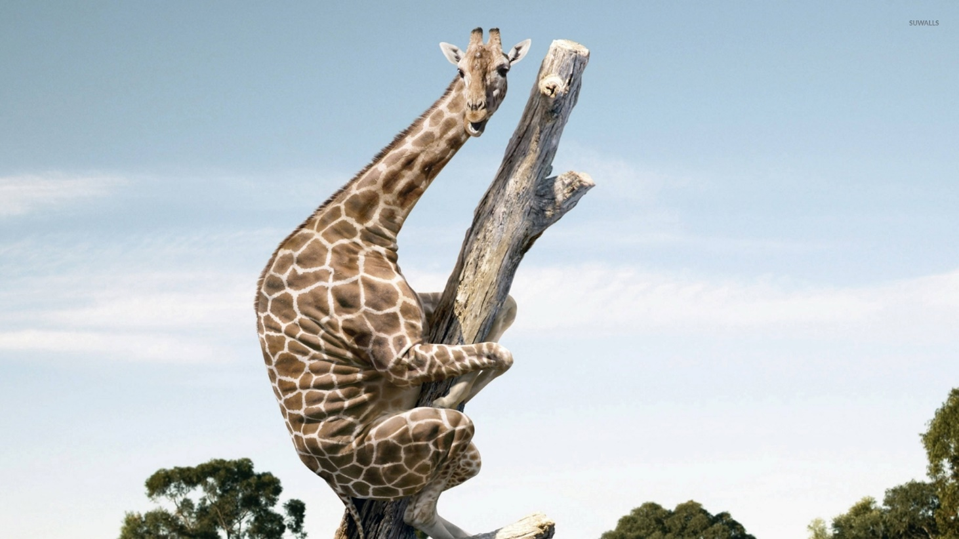
How did it get up the tree? Why is it up the tree?

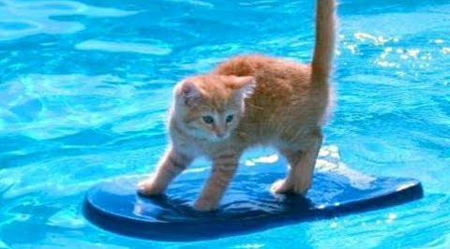

How did the cat get on the surfboard? What happens next?
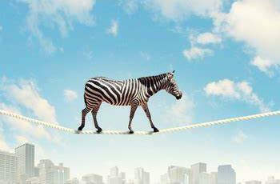

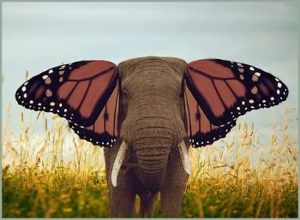
How is the zebra feeling? Do you think he makes it all the way across?
What happened to the elephant? How? What could his super power be?

