Stingray 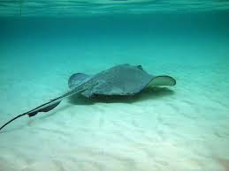 | Polar bear 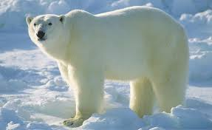 | Howler monkeys 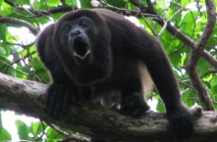
Giraffe 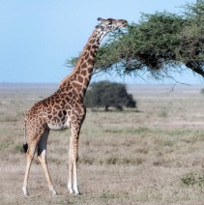 | Lion  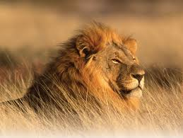
Habitat: Desert | Habitat: Aquatic/ marine | Habitat: Polar/ Arctic
Habitat: Rainforest | Habitat: Grassland | Habitat: Rainforest
 |  | Eyes on top of head to look around while swimming
Mouth at the bottom of head to eat food from the forest floor | Bury themselves to escape predators; can breathe even while buried | White fur to camouflage themselves in the white surroundings
Thick layer of fat under their skin to keep warm | Big paws with long hair to keep from slipping in snow | Use their loud voices to call out to others as it is hard to see in the forest canopy
Sandy-brown fur to camouflage and hide from preys | Have a strong sense of smell to smell fruits from trees that are 2km away! | Can wrap their tail around tree branches so they don’t fall down
Use their long, sharp claws as weapons to kill and eat prey | Sleep in the day to escape the dry and hot Savannah weather | Are herbivores and get moisture from the leaves they eat
Can reach leaves from tall trees with the help of their long necks | Can see far away because of their height so they can see predators from far away | Have sharp thorns to protect themselves from animals

