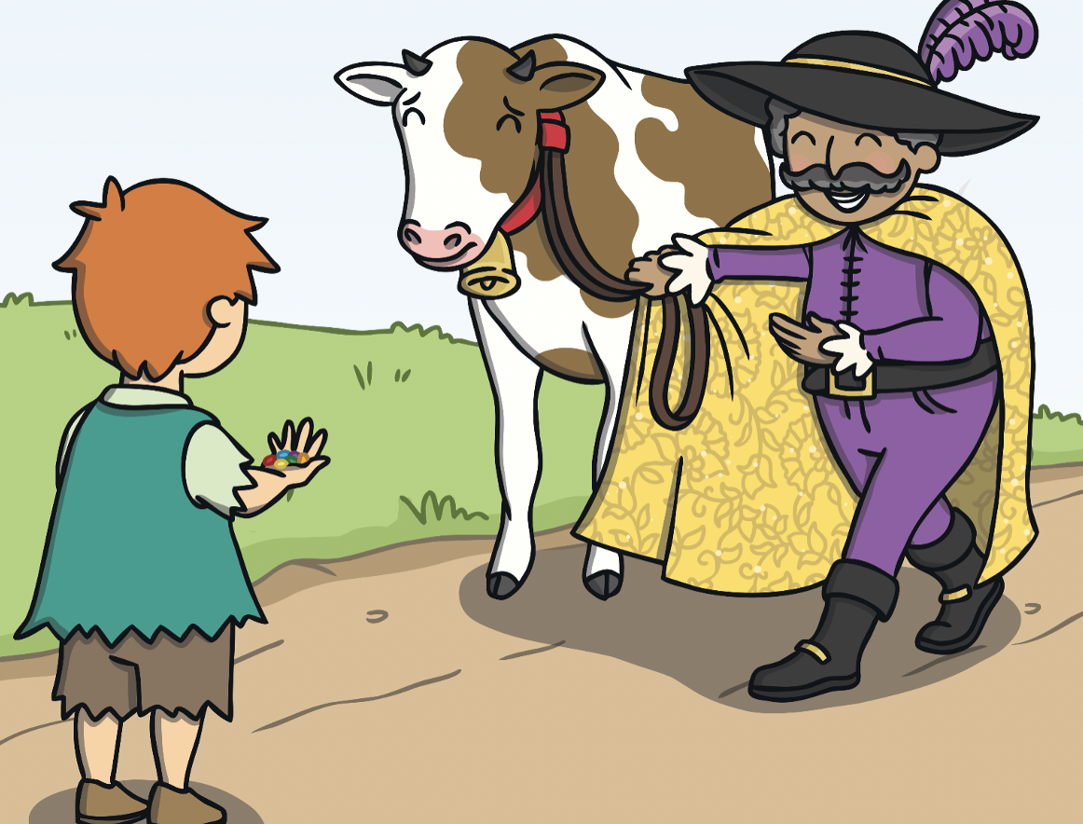
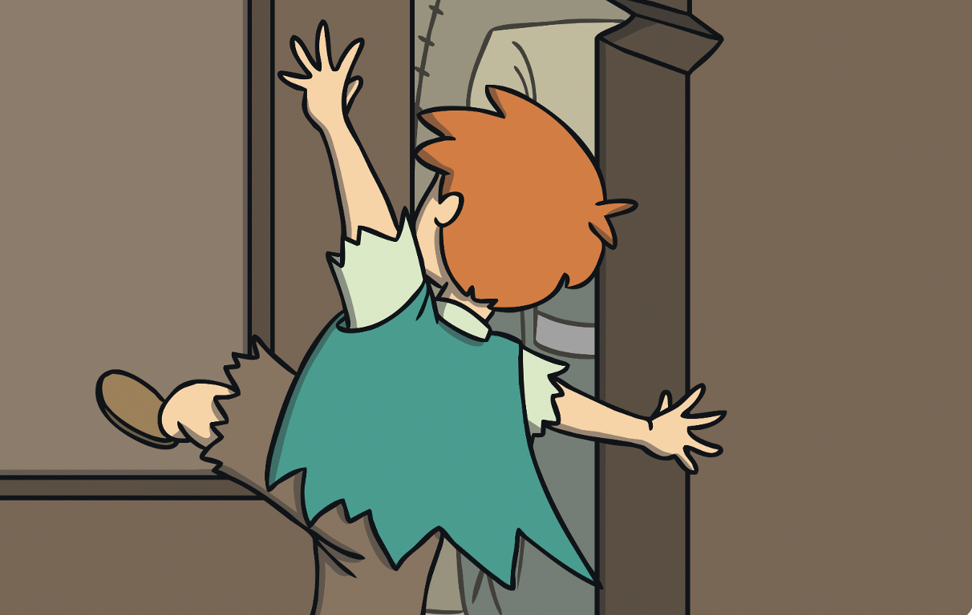
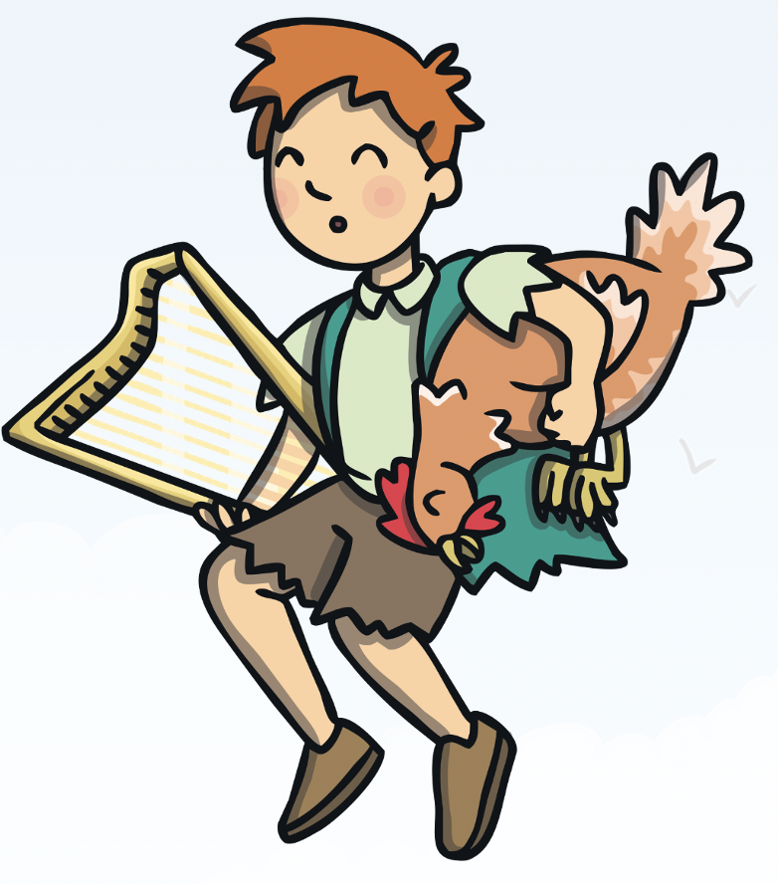
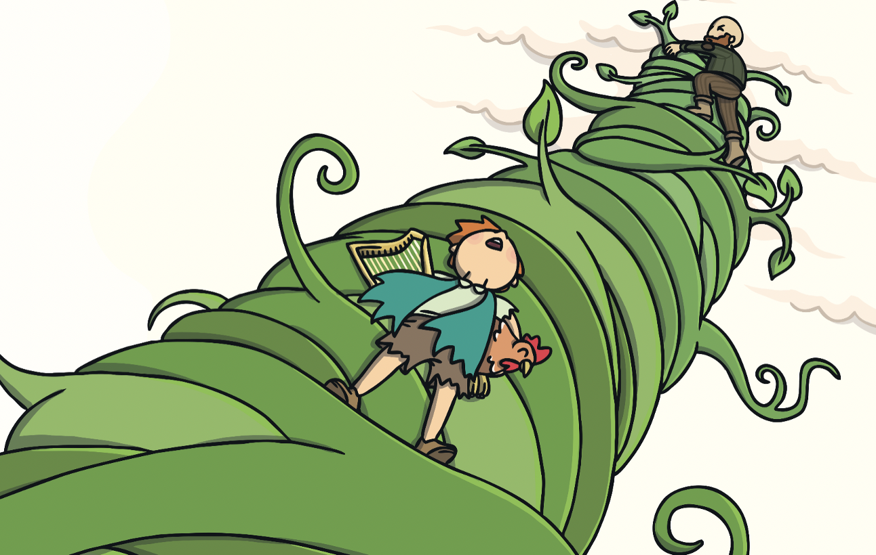
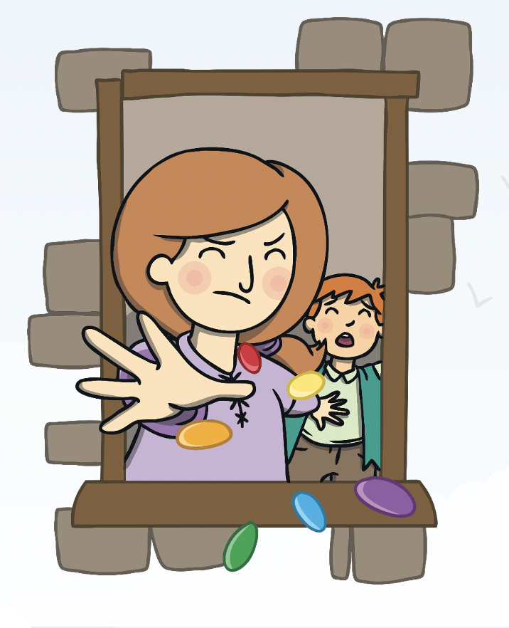
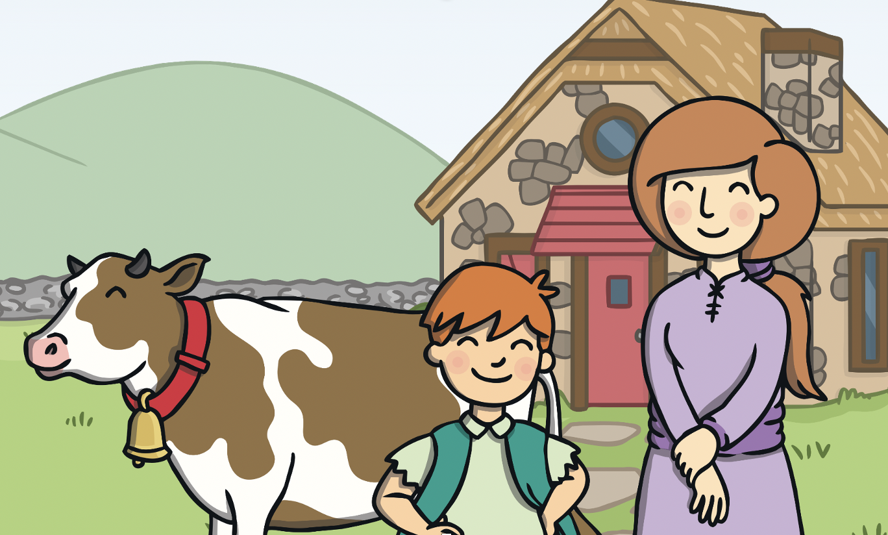
Wednesday 2nd December
LO: I can use the conjunctions ‘and’ and ‘but’ in my writing.

Look at these pictures from the story of the characters doing two things at once.
Write a sentence for each using the conjunctions ‘and’ or ‘but’.
Jack heard… _________
___________________
___________________
______________________________________

Jack slid… _____________
____________________________________________________________________________________
Jack picked up… _______
____________________________________________________________________________
Jack took…_____________
__________________________________________
_____________________

Mother threw… __________
______________________
______________________
_______________________

Jack lived with his mother and their cow in an old cottage

