Your thoughts
Imagine you are Jack. Write down the 3 reasons why you think you were right to steal the giant’s golden hen and harp.

2________________________________________________________________________________________________________________________________________________________________________________________________________________________________________________________________________

3________________________________________________________________________________________________________________________________________________________________________________________________________________________________________________________________________
1_______________________________________________________________________________________________________________________________________________________________________________________________________________________________________________________________________

Your thoughts
Imagine you are the giant. Write down the 3 reasons why you think you were right to be very upset with Jack.

2________________________________________________________________________________________________________________________________________________________________________________________________________________________________________________________________________
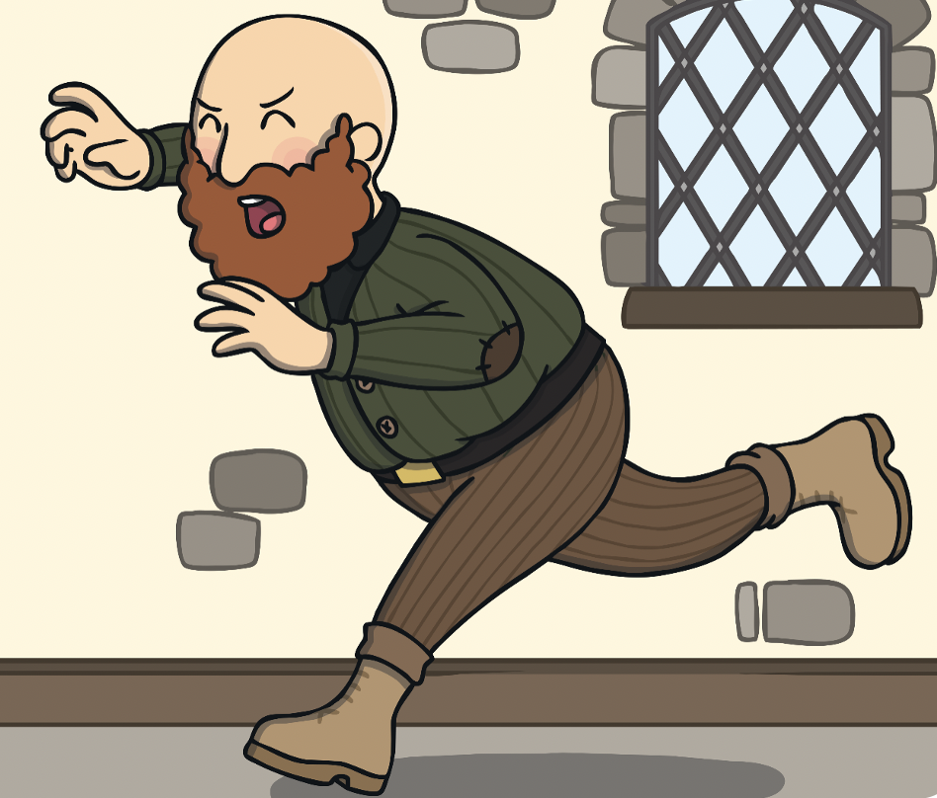
3________________________________________________________________________________________________________________________________________________________________________________________________________________________________________________________________________
1_______________________________________________________________________________________________________________________________________________________________________________________________________________________________________________________________________

