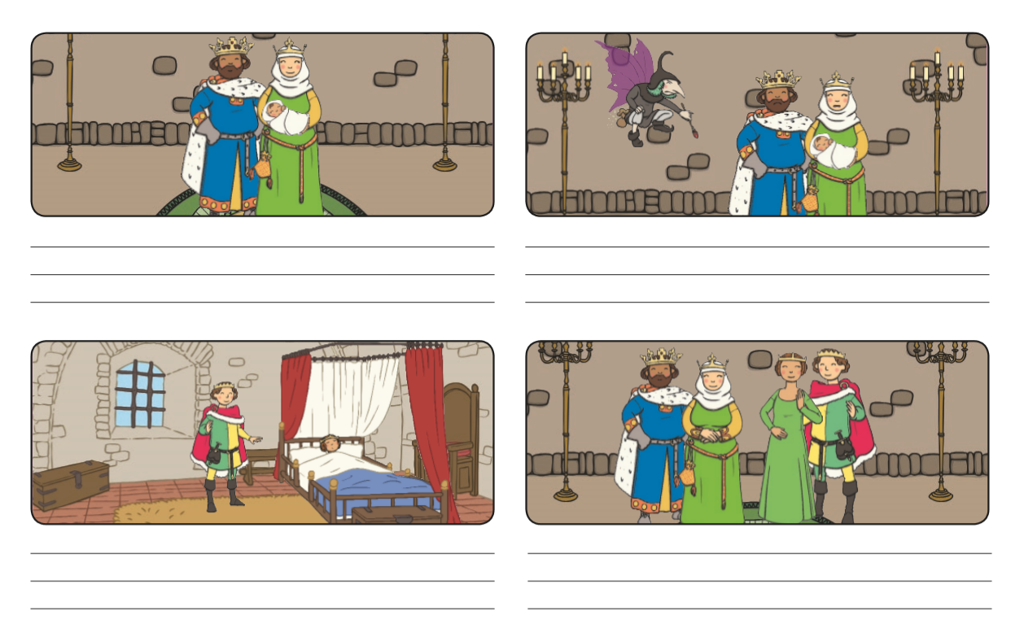
Years later, the girl hurt her finger and fell asleep for a long time. After that a Prince found the girl in bed fast asleep.
One day a wicked fairy said the baby will hurt her finger on a spindle.
Once upon a time there was a King, Queen and Baby who lived in a castle.

