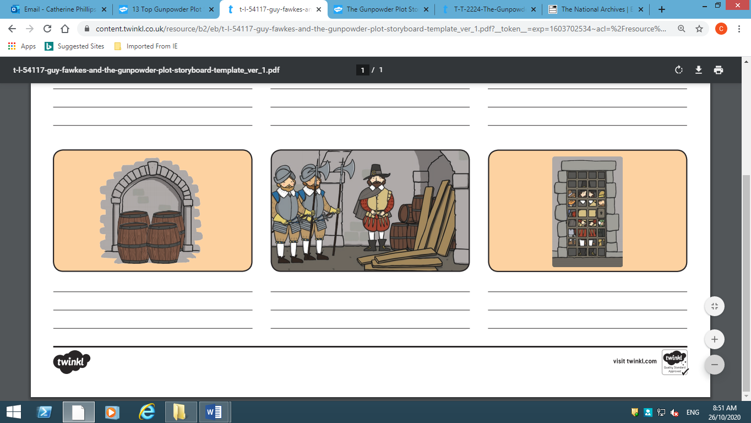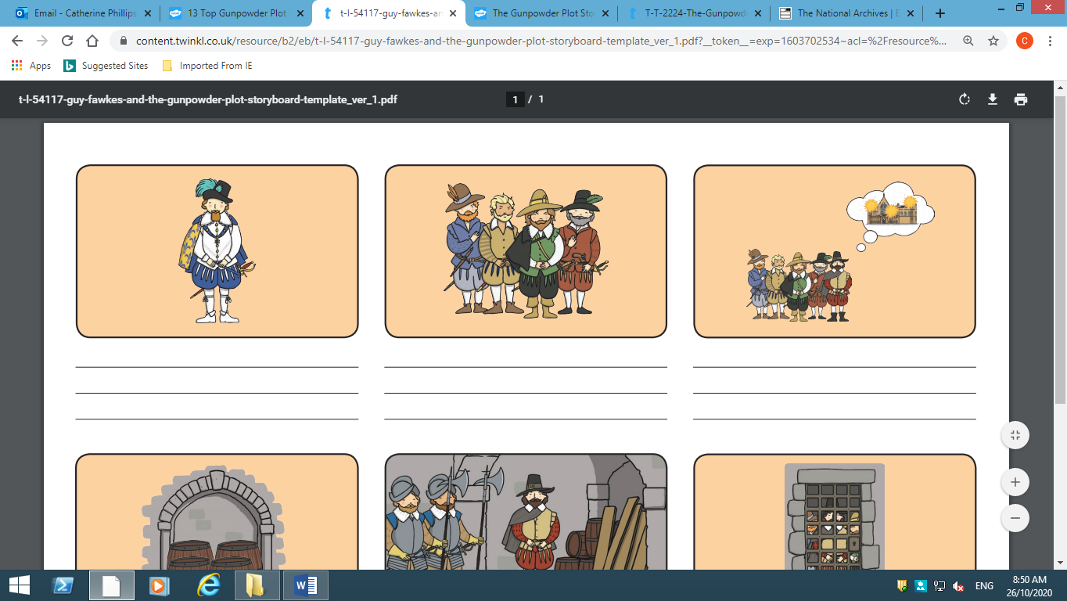
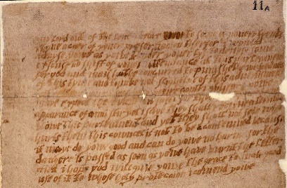

King James Catholics Protestants
Guy Fakwes friends Houses of Parliament
gunpowder barrels cellar
anonymous letter warning
captured tortured executed

