Joining blocks

Introduction
Can you follow the algorithm to see where the cat sprite goes? Circle the correct picture.
Remember to use Start and End blocks.

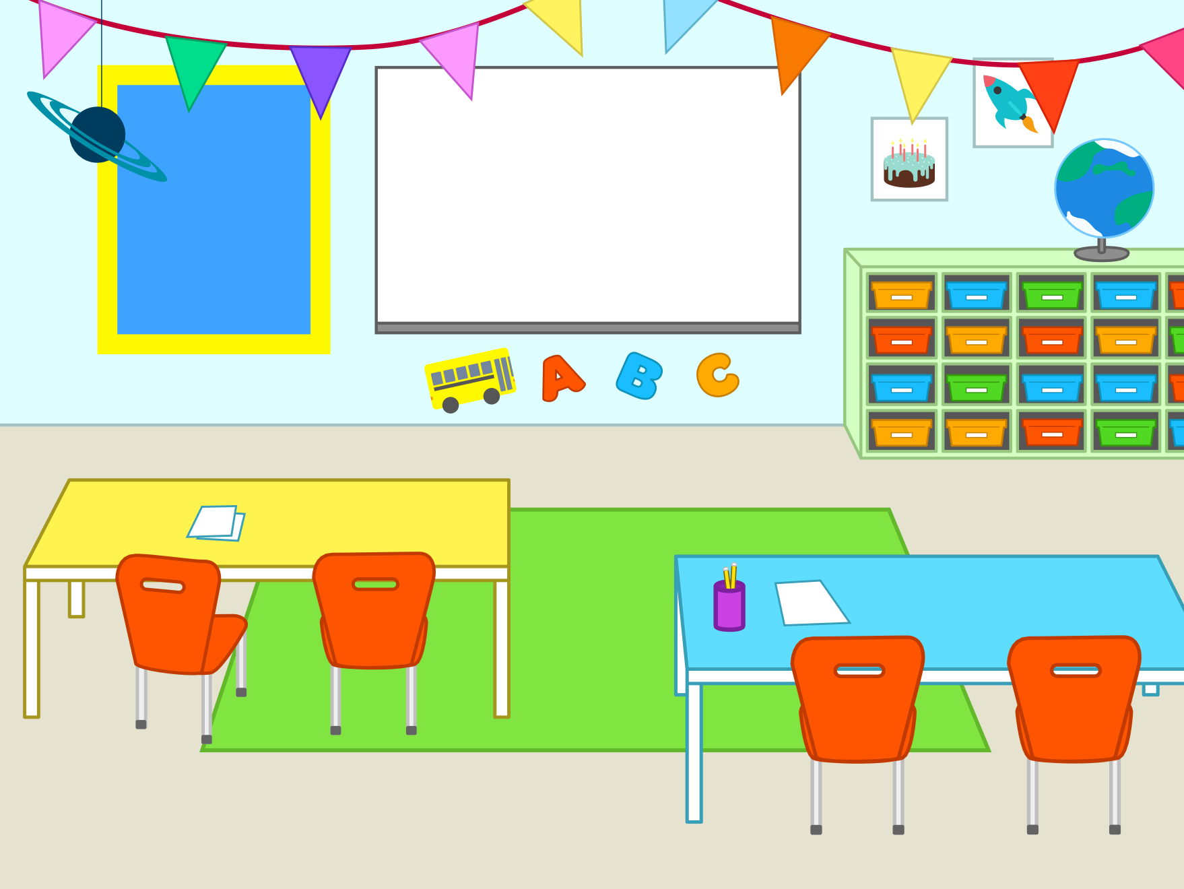

Use the Classroom background:

Algorithm: Start ↑ ↑ ↑ → → → → End
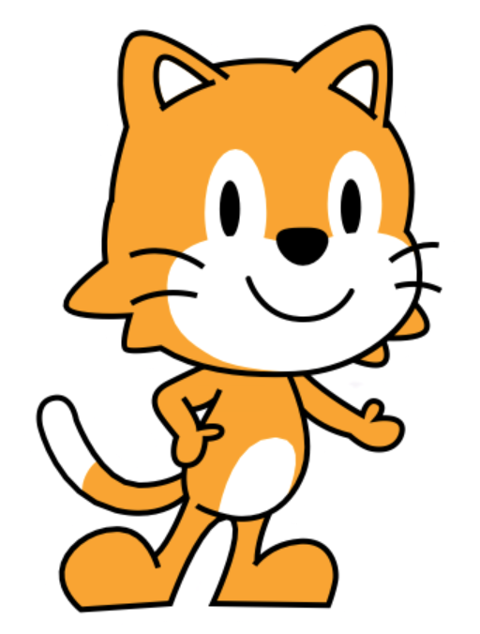

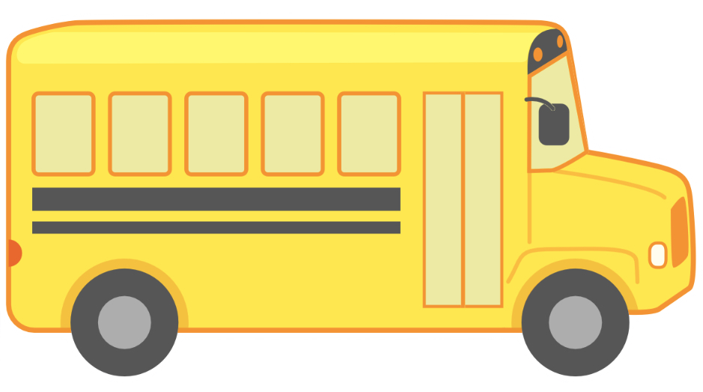




Algorithm: Start ↑ ↑ ↑ ↑ ← ← ← ← ← ← End


Algorithm: Start ↑ ↑ ↑ ↑ → → → → → → → → End

This resource is available online at ncce.io/pg1b-2-a2-w. Resources are updated regularly — please check that you are using the latest version.

This resource is licensed under the Open Government Licence, version 3. For more information on this licence, see ncce.io/ogl.

