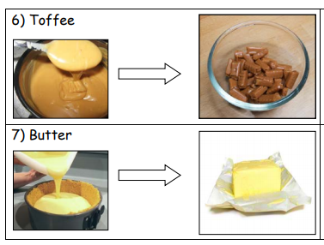
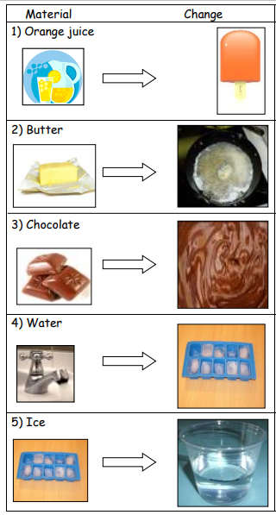
Reversible Irreversible
Heated Cooled
Reversible Irreversible
Heated Cooled
Reversible Irreversible
Heated Cooled
Reversible Irreversible
Heated Cooled
Reversible Irreversible
Heated Cooled
Reversible Irreversible
Heated Cooled
Heated Cooled
Reversible Irreversible

