Maths
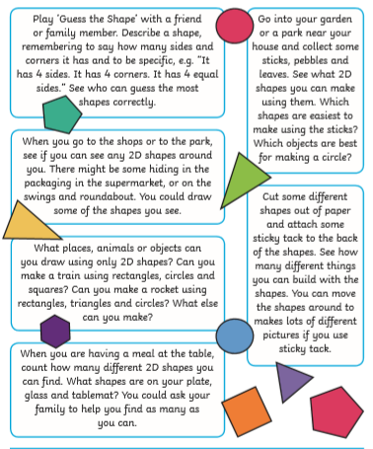
Focus – 2D Shapes

Please find other documents that I have uploaded.

