Year 3
Topic Task
Week beginning 30.03.20
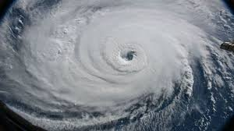
Task 1
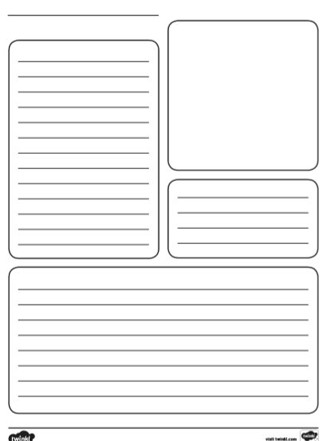
Research all about hurricanes.
What are they?
How are they formed?
Where do they occur the most?
What effects do they have?
Task 2
Create a fact file about hurricanes.
You can either create your own or use the fact file template.
Task 3
Create a piece of hurricane art.
This can be as creative as you like.


Here are some ideas.


