Year 3 Writing Tasks
You will be writing a diary entry based on the events of the school closure.
Task 1 – SPaG Test 5
You have completed many of these before. Remember to read the questions twice over. Once you have finished, check your answers twice over.
You can then mark your work using the answer sheet.

Task 2 – Create a feelings graph.
How have you felt about the school closure since Friday?
Have you had a range of emotions?
Create a feelings graph to show how you felt during the start of the school closure. Can you think of better words than sad and happy using a thesaurus?
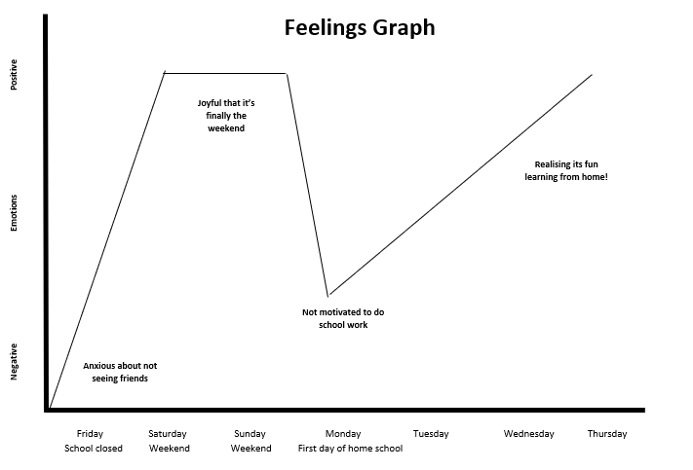

Task 3 – Plan your diary entry.
Think about: Friday, the day that the school closed. How did you feel?
What activities have you been doing? What emotions have you felt?
What has it been like doing school work at home?
Task 4 – Read through the diary entry checklists.
Choose a checklist that suits you best. Can you include all of those features?
You will use this when writing your diary. Tick off a feature when you have included it.
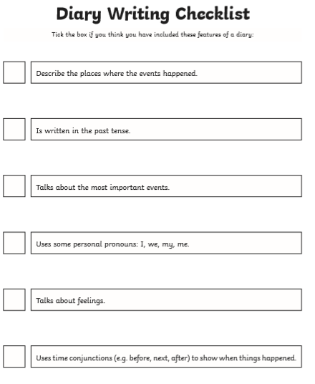
Task 5 – Writing your diary entry.
Remember to include all of the correct features and the Year 3 Writing Objectives which you will find in the front of your text book. Use emotive language and engage the reader.
I look forward to seeing your amazing diary writing skills!

