Year 3 Writing Tasks
You will be writing a newspaper report based on the events of Pompeii and Mount Vesuvius.

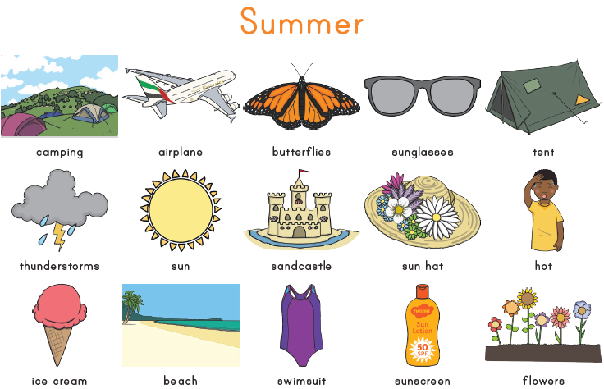
Task 1 – What vocabulary or adjectives are used for volcanoes? Create your own word maps. Below is an example of a word map for summer.

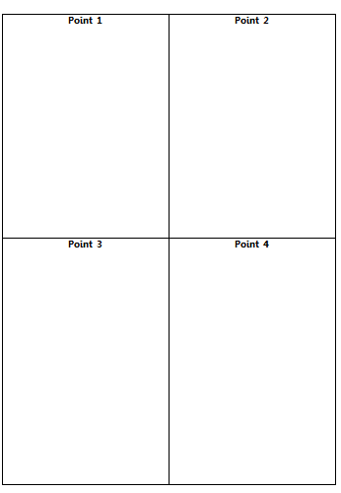
Task 2 – What were the main events of the volcanic eruption in Pompeii?
Research the events of Pompeii – summarise them into 4 points.
How would people feel during each event?
What could you see?
What would people say if they were there?
Descriptive words for each point
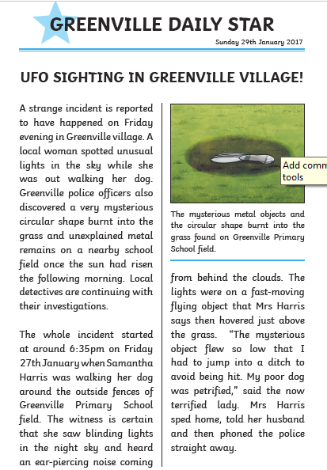
Task 3 – What are the features of a newspaper report?
Annotate the features of the newspaper report example. Including:
-Headline
-Date
-5 W’s in the first paragraph
-Pictures
-Paragraphs
-Columns
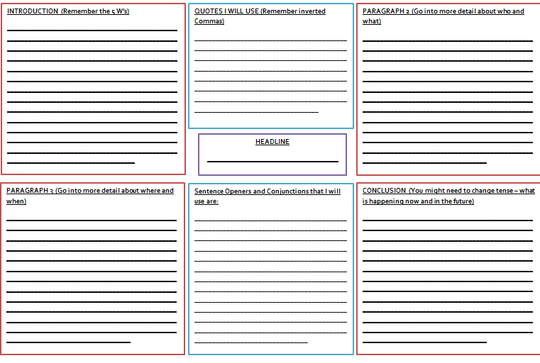
Task 4 – Plan your newspaper report.
Things to think about:
What is going to be the headline?
How can you answer the 5 W’s in the first paragraph?
What are your quotes going to be?
What pictures will you use?
What information will you include in the other paragraphs?
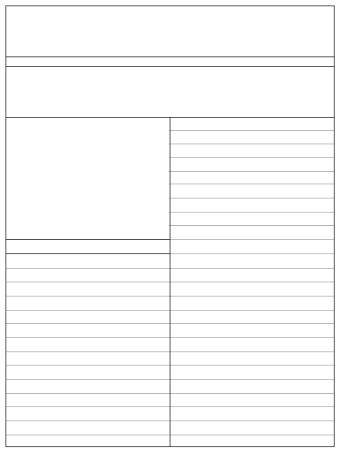
Task 5 – Writing your newspaper report.
Using the template write your article out. Remember to include all of the correct features and the Year 3 Writing Objectives which you will find in the front of your text book.
I look forward to seeing your super journalist skills!

