Now that you have chosen your sea creature, let’s begin to build our non-chronological reports.

Today we are going to focus on their physical appearance.

Use the videos and web site links on your class page to research key aspects of your animal’s physical appearance.
Use bullet points to help you record your findings in note form.

Physical Appearance – Blue Tang (Paracanthurus Hepatus)
What is the typical size of a clownfish?
Think about the colours and how this would help it survive in its habitat
Parts of its body

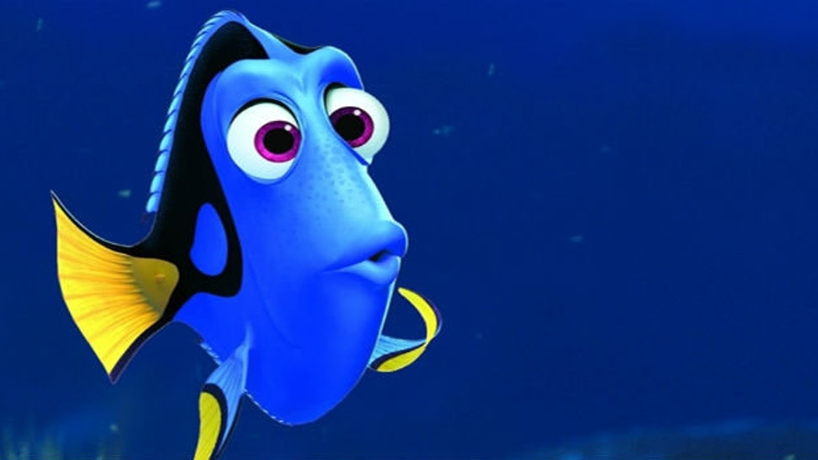

Now that you have gathered your notes, transform your findings into a paragraph.

The Appearance of a Blue Tang
________________________________________________________________________________________________________________________________________________________________________________________________________________________________________________________________________________________________________________________________________________________________________________________________________________________________________________________________________________________________________________________________________________________________________________________________________________________________________________________________________________________________________________________________________________________________________________________________________________________________________________________________________________________________________________________________________________________________________________________________________________________________________________________________________________________________________________________________________________________________________________________________________________________

