Today we are going to focus on the diet of your chosen animal.

Use the videos and web site links on your class page to research key aspects of your animal’s diet.
Use bullet points to help you record your findings in note form.

Diet – Great White Shark
What do they eat?
What don’t/can't they eat?
How do they find their food?
Are they carnivores, omnivores or herbivores?
Do they eat different things as they grow?
Do they chew their food?

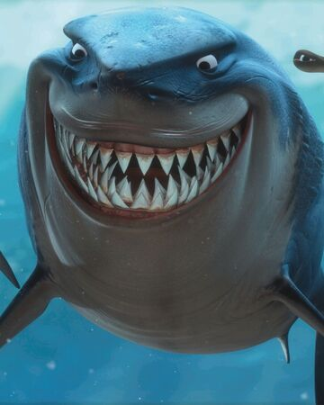

Now that you have gathered your notes, transform your findings into a paragraph.

The Diet of a Great White Shark
________________________________________________________________________________________________________________________________________________________________________________________________________________________________________________________________________________________________________________________________________________________________________________________________________________________________________________________________________________________________________________________________________________________________________________________________________________________________________________________________________________________________________________________________________________________________________________________________________________________________________________________________________________________________________________________________________________________________________________________________________________________________________________________________________________________________________________________________________________________________________________________________________________________

