Water-gun hide & seek
Water-gun hide & seek is a fun, wet, physical game to be played outdoors, in the summer months.
I hope you have a drenching good time …
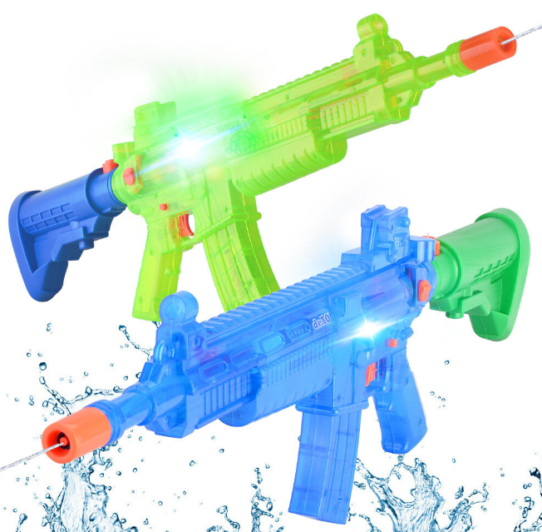
Equipment
You will need:
Water guns,
Water,
Towels,
Spare clothing
And
A sense of adventure…

How to play:
- This is a game for three or more players.
- The aim of the game is for the seeker to drench the other players before they manage to pick up the winning water gun from the base station and become the new seeker.
- First of all, someone has to volunteer to be the first seeker.
- A base station is nominated where the seeker counts, the winning water gun is stored, and the other players have to get to during the game to win.
- The seeker counts to thirty without looking, whilst the other players hide.
- When the count has ended, the seeker collects their water gun and shouts: “BETTER HIDE OR YOU’LL GET DRENCHED!!!”
- Players try to get to the base station without being drenched and the first person to do this is the winner, and gets the winning water gun to become the next seeker.
- If everyone gets drenched the original seeker continues for another round and gets to stay dry.....

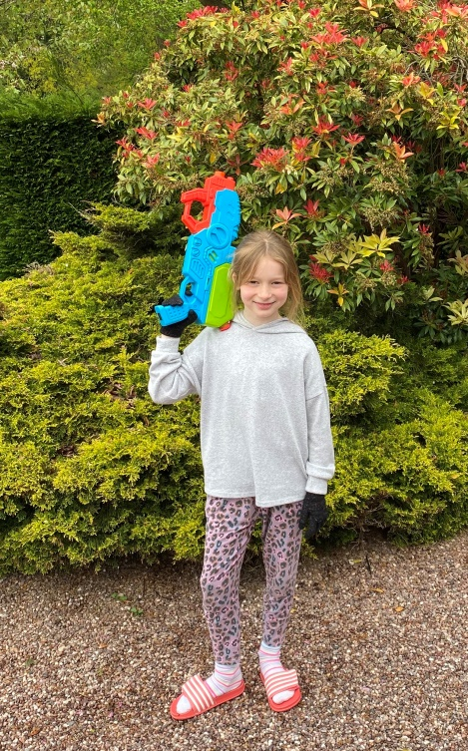
Enjoy getting drenched everyone….

