Dragonworld
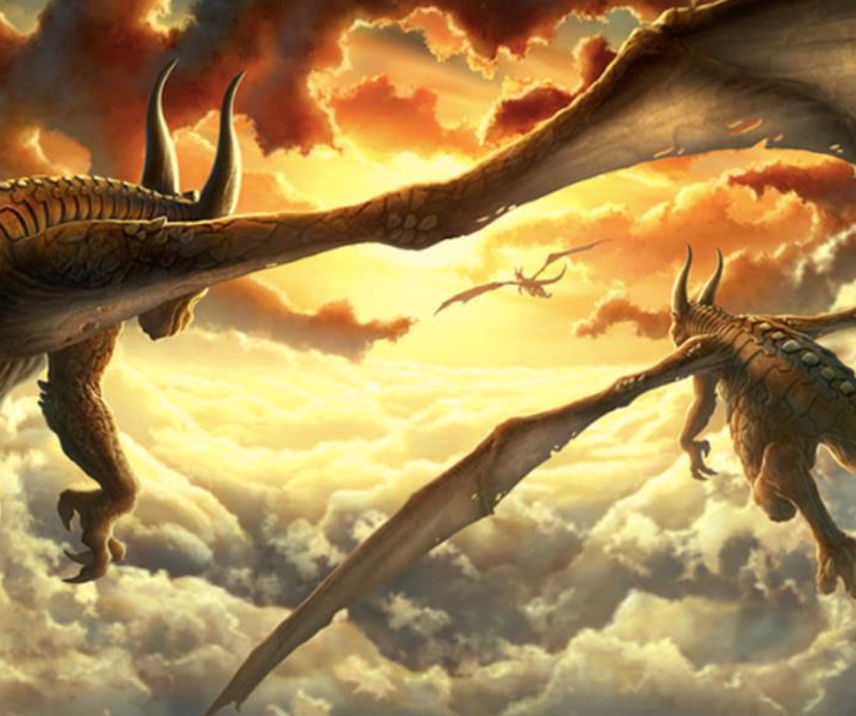
Now that you have chosen your picture, you have the choice for your genre.
- Story – complete the story from the a story starter
- Diary Entry (from a dragon’s perspective)

Task 1: Question Time
- Where are the dragons heading?
- What is ‘paradise’? Why are they looking forward to it so much?
- Are these the only 3 dragons that exist, or are there more?
- Where have the dragons come from? Where is their home?
- If you had a pet baby dragon, how would you look after it?

Task 1: Vocab Collection
Use the target below to gather vocabulary that you can use in your writing. Think about:
- Adjectives
- Similes
Once you have your initial ideas, think carefully about where you place them onto the target. Place your most powerful ideas in the centre of the target, and the ideas that still require improvement (pink polished), place around the edge.
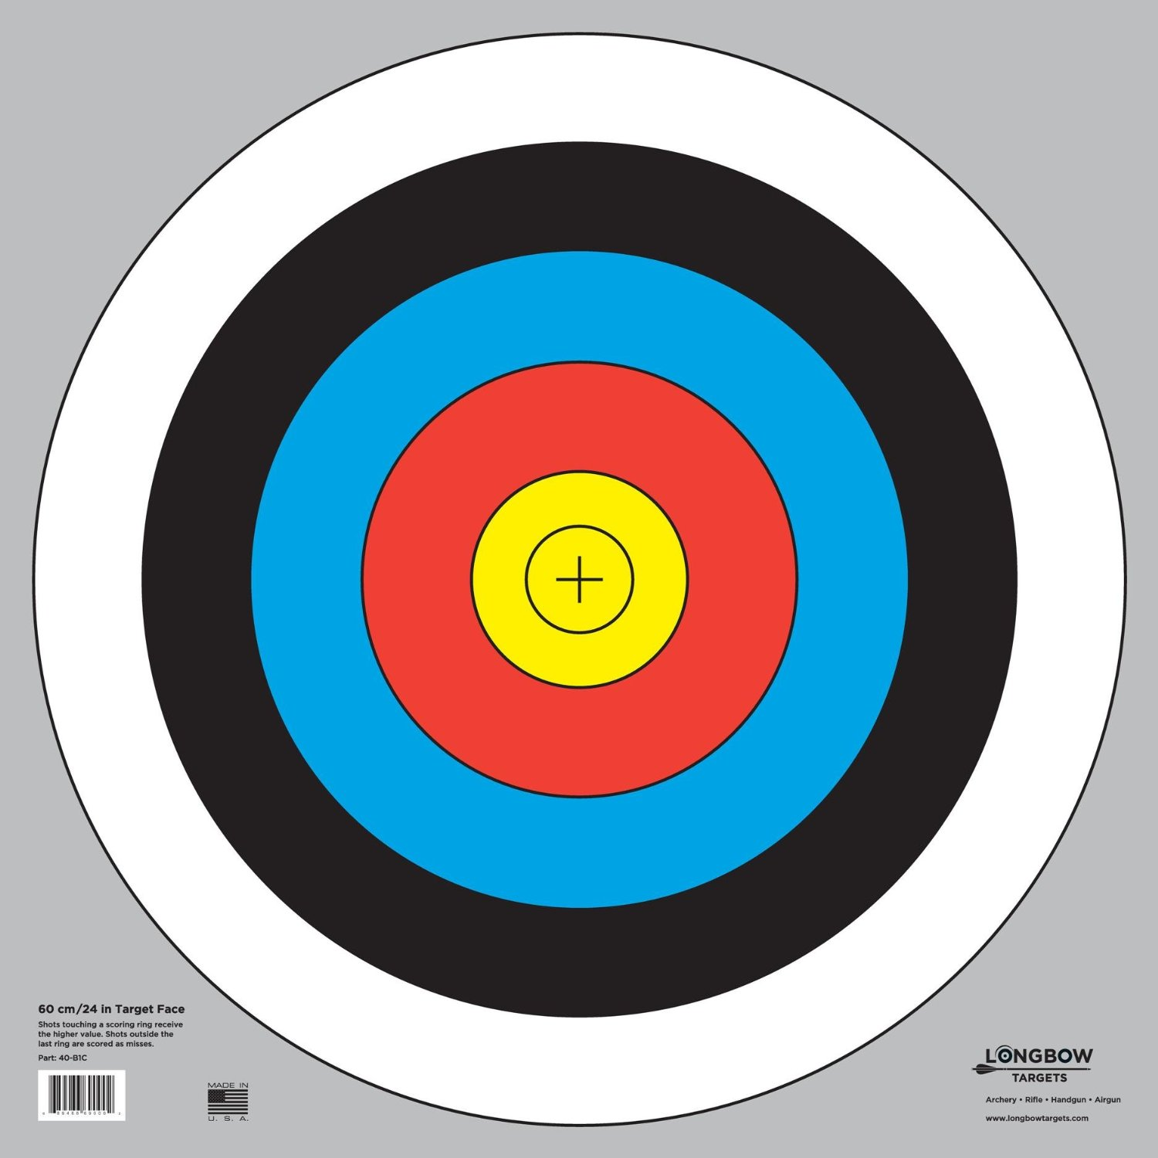
Colossal
Exquisite
Giant
Unique
Big
Different

