Dear Year 3,
My name is Miss West and I am going to be your teacher in Year 4. As you have probably guessed, I am new to Cooper Perry, so I am feeling a little bit nervous but very excited about September and cannot wait to meet you all! I thought it would be helpful for me to write to you, to tell you a bit about myself and what to expect in Year 4.
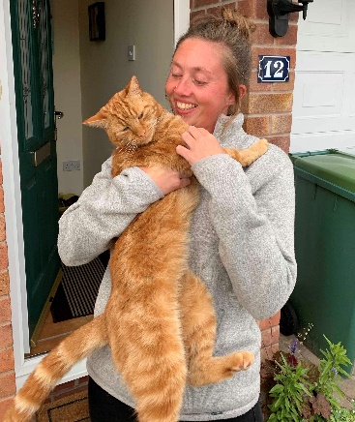
Firstly, I love drinking tea and eating Jelly Tots, though one of my favourite foods has got to be a Greggs sausage roll because they are so tasty! I love reading and my all-time favourite book is, ‘The Tiger Who Came to Tea’ by Judith Kerr, although I also love the Harry Potter books by J.K. Rowling. I especially like sitting in the garden reading and enjoying the sunshine. My favourite subjects are English, Geography, Music and Art. I play the clarinet and piano and really love singing with a choir. I cannot wait to hear the choir at your school! I enjoy swimming and the outdoors, so I go on lots of interesting walks to new places. Once a week I volunteer at a Guide unit, which is great fun! I wonder if you are in a club, or Girlguiding / Scouting? My favourite part is going camping and cooking marshmallows on a fire. At home, I have a big ginger cat called Marley, who likes to think that he is a tiger prowling around the garden. I have a brother and sister who are both younger than me and we enjoy spending time together.
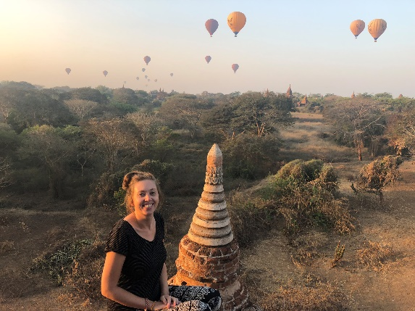
I have recently been on an amazing travelling adventure to South East Asia and Australia! I had lots of great experiences such as feeding elephants, swimming with whale sharks, visiting temples, meeting people from different cultures and even teaching two boys on a cattle station in the Outback!
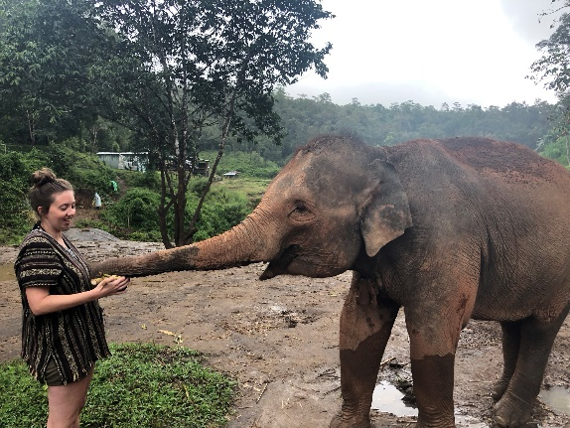
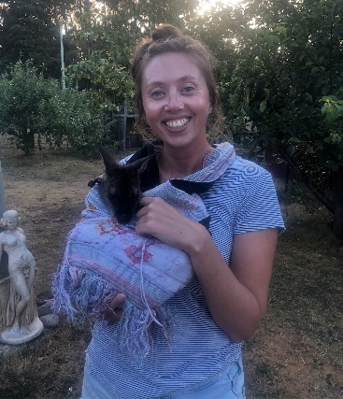
I know that most of you will have been away from school for quite a while and you will probably have a mixture of feelings about September. Remember that it is ok to feel nervous, anxious, or excited. There will be lots of us in school feeling the same way and we will all be there to support each other.
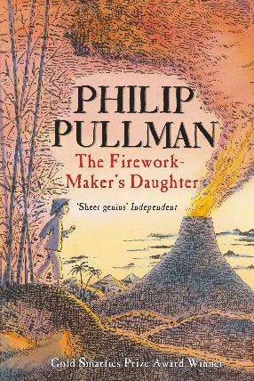
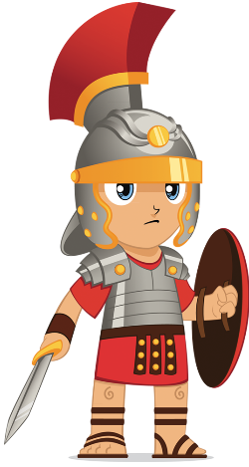
Year 4 is my favourite year group, so it is going to be lots of fun! Our first topic of the year is Roman Rule, so we will be learning all about the Romans! In English, we will be reading a brilliant book called, ‘The Firework Maker’s Daughter’, by Phillip Pullman.

I would love it if you would write back to me and tell me all about yourself! You could include things such as your hobbies and what you enjoy doing outside of school, your family, favourite food, subjects you enjoy, favourite book and anything else you’d like me to know. Because I am new to Cooper Perry, it would be great if you could tell me what you love most about school.

I look forward to hearing from you and cannot wait to meet you all, ready for a fantastic year together as Year 4!
Stay safe and keep smiling!
From Miss West

