Outside Game Instructions
Think about all the different games you can play outside. Whether it’s a game you play at school on the field or playground or games you play in your garden. Your task is to write instructions telling how to play your favourite outside game.
Task one – Write down as many outside games that you can think of that you play. They can be games to play as a group or on your own.

Task two – choose on of these games. Now you need to break it down. Create a mind map like the one below which will help you when writing your set of instructions.
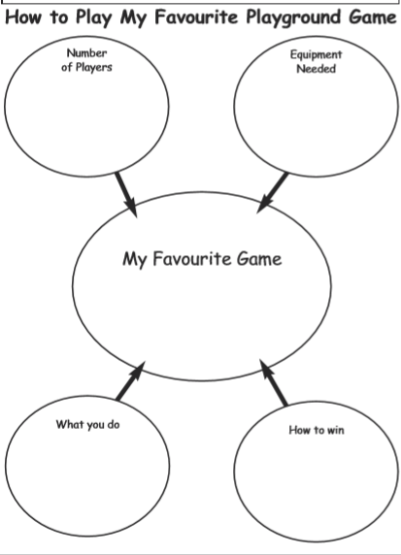

Task 3 – Read through the example text.
Can you identify the main features?
Look for:
- Headings/subheadings
- Numbers to separate the steps
- Introduction sentences
- Imperative (bossy) verbs
- Conclusion sentences
- Adverbs/conjunctions/prepositions
- A list of what is needed
- Steps in chronological order
Task 4 – Write your set of instructions using the checklist (on website).
Remember to use the Year 3 Writing objectives. Also, could you include any pictures in your instructions? Maybe this would help make it clearer?
Present your instructions as neatly as you can. We will be looking for more handwriting pens to be handed out when we go back to school!

Have fun!
Miss Simpson
P.S. Send me your set of instructions and I can share them on the website. Therefore others will be able to play your game using your instructions!

