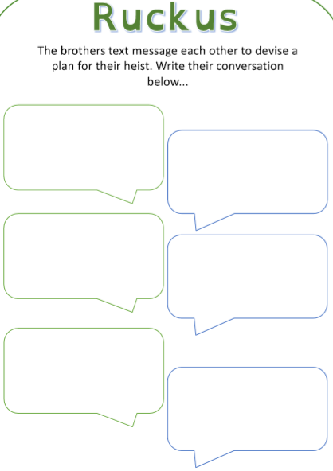
Morning Mike,
That wanted poster is all over the town! Like they’d ever be able to catch us anyway.
Tell me more about this plan… where is this diamond? Seems a bit unrealistic to me mate.
Reply ASAP.
Dan
Hey Dan.
I saw a ridiculous wanted poster of us today! We can’t have people knowing that we are thieves as what would Mum and Dad say?
I have plan for our next heist. It involves something that I think you might like. Ever held a red diamond before?
See you soon.
Mike

