Year 3 Science Tasks
All flowering plants go through the same stages of the life cycle.
The main stages are germinations, growing and flowering, pollination, fertilisation and seed dispersal.
Task 1: Research each stage of a plants life cycle and explain what they mean and what happens during that stage.
Task 2: Can you design a way to represent the stages of the life cycle? You could:
- Draw the different stages on a paper plate, adding arrows to show the order.
- Make a poster to show the different stages.
- Create a small book with one stage on each page.
- Write about what happens at each stage in the form of a fact file.
- Make a PowerPoint with one stage on each slide.
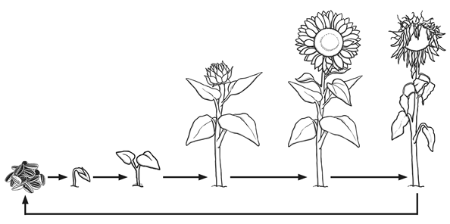
Or you could come up with your own idea!

