Let me tell you about a story about myself. Before I do, I would like to tell you nothing will ever be as cool but scary as this. Now I was 12 and I was nearly be teen, but this was a nightmare that had come to life.

I was at school playing netball at lunch when I felt a gush of wind against the back of my neck. I turned around to see a swirl of light coming from behind a tree. There was mist coming towards me; it was a light blue colour. The thing is none of my friends could see it… Only me. As it was coming closer it started pulling me in, I was sucked up in a portal…

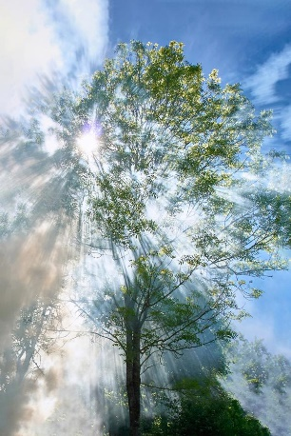
The world went weird. My friends all disappeared.

Where am I? Will I survive? Does school end soon? Will I get in trouble? Will mum care? I thought I would die. When you’re in a dark room and your starting to feel claustrophobic, you begin to freak. I took a picture of the world I am in.
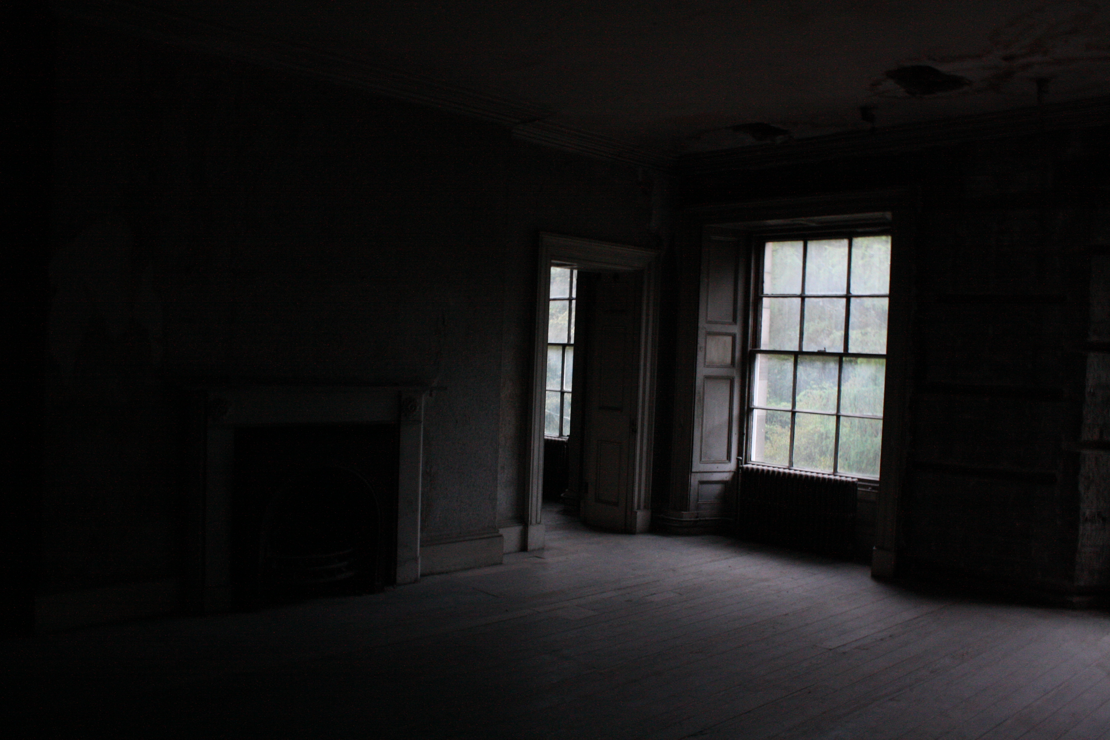

I started to make my way out of the room when I heard a psst. I looked behind me and saw a half lion and half man locked up in chains.
“Hello?” I said.
“Hello, young… Young,” He said
“Boy” I replied.
“Aah, yes I have met a boy before and I took care of him, till, never mind whats your name chappy?” He said.
“I am Thomas, what’s your n… n…name?” I replied.
“My name is Jimmy; will you help me escape?” He asked.
“Escape from what?” I replied.
“Escape from sapphire, she is the devil queen half snake half human.” He answered.
“Ok but how, snakes are so fast?” I questioned.
“I know she is fast, but I will also help you, if she sees a human, one bite you’re a ghost and you get washed out everyone’s mind,” He told me.
“We better get out of here then,” I said.

I managed to break him free, it took a long time as I am very weak. We made our way down and managed to go to his hut; underground. We heard someone coming. We had to run. The devil queen can sense me from miles away! I told him that I know where the portal was and that if I go, he can’t come as if he leads everyone here my world will be attacked. We went back to the dark room and the portal was nowhere to be found. We looked in cupboards, we ran into walls, we lifted the sofa and face planted the floor; it was nowhere to be seen.

Jimmy said If I can find the portal at midnight, he should be able to come through and change to human; he had been there since he was a 12-year-old boy, he is now 22. He raised himself and worked as a paper man.

It was 11:30 pm and I told Jimmy to focus and try and remeber where the portal was when he came here. He said near the cupboard, but we already looked: in it, beside it, and on top of it. But I think we didn’t look behind it! THAT’S IT! We moved the cupboard to see the mist and the light. 1…2...3 JUMP! We were free, I lead jimmy to my house and we partied all the way! Mum said he can stay, and he is now my big brother.

I am writing this sat with Jimmy! I am 13 now. IT’S MY BIRTHDAY! 22/05/1945. Bye.

