Future cars

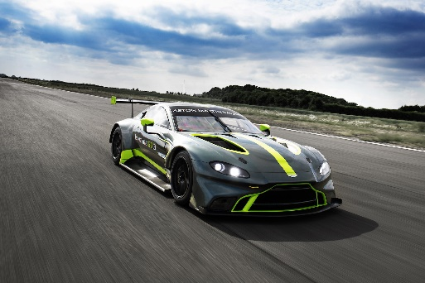
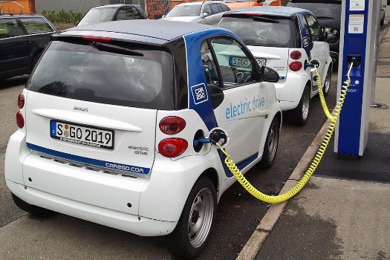

Electric car Race car look

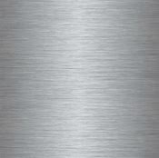
I think Electric as when people were protesting, they said that more Electric cars should be used to help with reducing pollution. I also think a race car look as more people have started to buy race cars or cars that look like them. I think there will also be a choice of what look your car should be. Some Examples are:



Silver Red Black Gold.

