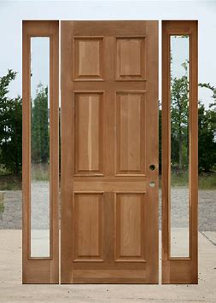
Once there was a normal looking oak door that was standing in THE MIDDLE OF THE ROAD! But no one noticed. It sat there for over 5 months, so I decided enough is enough, I need to see what’s in there.
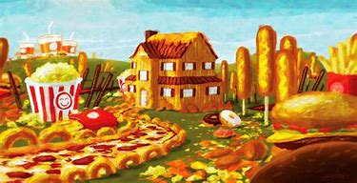
So, I decided to go through it but then I saw it… I saw a land made of food!! It was raining nachos with a nacho cheese pool with everything I wanted; even all the buildings were made out of cheese. Along with consoles that are made of hot dogs. Everything was made out of food; it was a dream come true.
And that wasn’t all, every building was made out of pizza even the glass and windows are made out of onion rings. But I accidentally ate most of the people because they were made out of doughnuts. They were really mad, I must say.
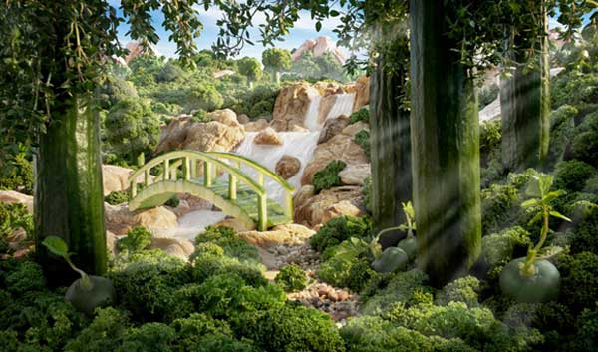
And so, they released an all junk food monster on me. It seemed to be immortal and every time I ate it, it kept on growing but I found a way; peeling it out of its skin and eating it. I made a run for it but they released 50 more monsters. It took me 2¹/₂ hours to do it and I saw it… I saw the door from 50 miles away. And after running for 50 miles I was right by the door and when I went through the door I saw a forest made of heathy food (since I went through a door made of nothing but food).
The door disappeared and there was another one nearby, I needed to go there but there was a giant wall made out of pepper in my way and I had to eat it; I forgot I had a knife in my pocket and so I carved the wall and then I saw a hall way of 1,000,000 doors that looked the same.
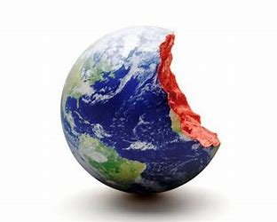
I searched for hours on end but on the 999’998th door, that still wasn’t the right one. But on the last door (the 999,999th door) I found it; I found the normal dimension where only food was edible. And for 4 weeks (30 days) I decided at night I will chop it into 1,000,000 pieces and I did. Literally I could of eaten the earth made out of food and in less than 24hours to. I will never open a random door again.

The End.

