New Science Topic: Inheritance and Evolution
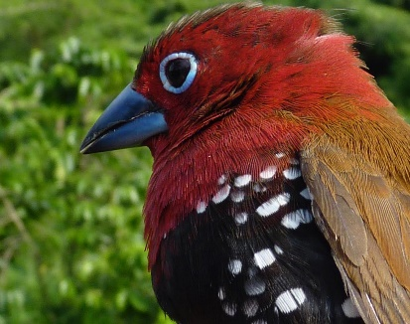
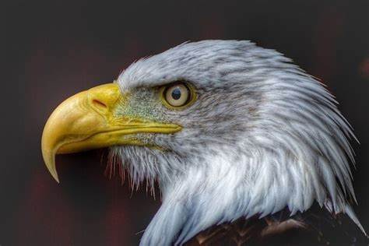
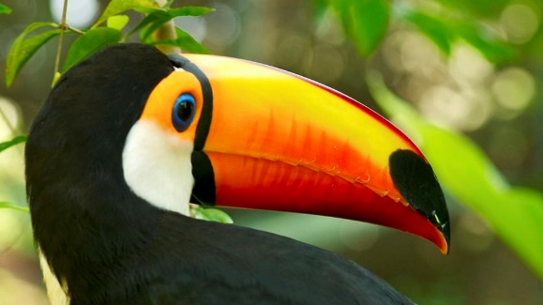
Seeds and Fruits – Adaptation

We are going to start the new topic with a fun experiment.
You will need:
- Different objects to represent bird ‘food’ (pipe cleaners, rice, raisins, playdough, bird seed, or any other items that you have at home that you think will work).
- Different objects to represent ‘bird’ beaks (chopsticks, spoons, tweezers, clothes pegs, small flat stones or any other items that you have at home that you think will work).
Best beak: You will make predictions about which beak will be the best shape for picking up different kinds of food and match the beak shape to the food eaten.
Introduction - Different kinds of birds eat different kinds of foods, because they are specialised. Their beaks have adapted to be the best shape for picking up the food they like best and is most available to them.
Task: In this experiment you will predict which ‘beak’ will be best for each ‘food’ type. Start by laying out the bird ‘food’ and the set of ‘beaks’. For each beak, predict which ‘beak’ you think will work best for that food, then test the ‘beaks’ to see if your prediction is correct, recording on the worksheet as you go (or in your book).
Photograph: It is always lovely to see how you’re getting on and how you are doing with your ‘home lessons’. If you want to capture your experiment, email your pictures to me!

