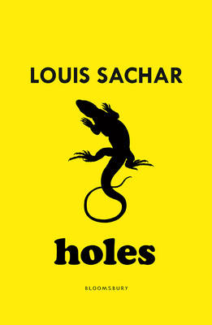
Reading Discussion – Making connections between texts
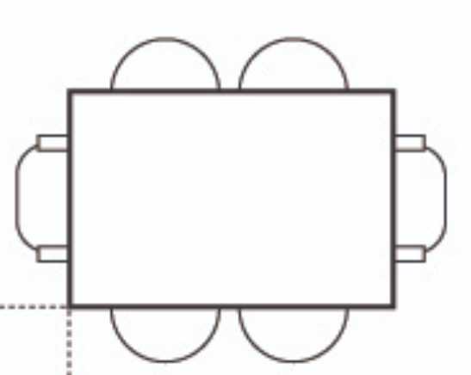
A table with 6 chairs: two on each side, one on each end.

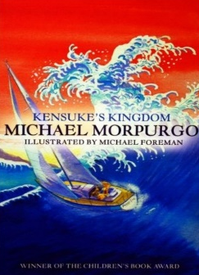
Your task involves sitting the following characters around the table above. You need to consider their character in relation to where you sit them and you also need to consider who you are sitting them next to. Normally, we would do this as a discussion, but as this is a home learning task, I would like you to explain why you have placed each character in the seat that you have chosen for them.

- Kensuke

- Michael

- Stella

- Mr Sir

- Stanley

- X-Ray

