The Smartest Giant in Town
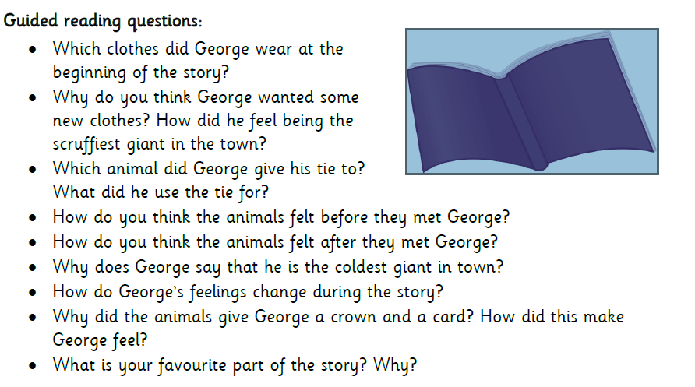
Adults please read or watch the story of The Smartest Giant in Town with your child then ask your child the following questions. There is no need to write anything down; it is a chance for you to discuss the story together. You don’t have to go through all the questions in one go maybe a few questions a day.

