Science: Light and Shadows
I can explain why shadows have the same shape as the object that casts them.
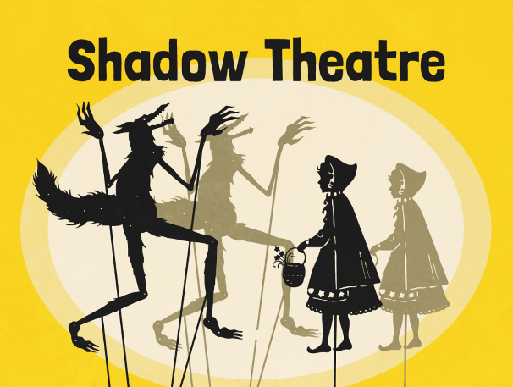

Last week
Shadows are formed when an opaque object blocks a ray of light.
Is a shadow always the same shape as the object that casts it? A shadow can change size depending on the distance the object casting it is from the light source. Shadows can also be elongated or shortened depending on the angle of the light source.
However, a shadow is always the same shape as the object that casts it. This is because when an object is in the path of light travelling from a light source, it will block the light rays that hit it, while the rest of the light can continue travelling. Therefore, the shadow it casts is exactly the same shape.

Today
Your task is to create a shadow puppet show. You will perform a short scene on a topic of your choice. This could be: a short story, a classic tale or a clip from a drama.
Puppet Making:
Use cardboard and straws or craft sticks to make your shadow puppets. Try and improvise with the resources that you have at home – card, kebab/lollypop sticks. Remember, your puppets will not need to have features or detail as your audience will only see their shadows in the performance.
Performing:
Think about how you can use your shadow puppets creatively - moving them closer to the light source to make them look bigger, or tilting them to change the angle. Once you have rehearsed your show, ask someone at home to record your performance or to take pictures (if this is not possible). Then if you would like to share it with me, email the video clip or photos - I would love to see your creations.

