Art Project: Plastic in the Ocean
I understand that all of you will have different resources at home however this project comes solely from your recycled plastic. Your task is to create a sea creature out of plastic. Now that you have had a week to gather your resources, I would like you to make a start on your art project. Remember to use your plan to help you.
As you know, the choice is yours: it can link to your chosen animal from your diary entry or it can be a completely different one. Remember, you don’t need to recreate one of the ideas below; you can create something original. They are just there to support you.
Ideas
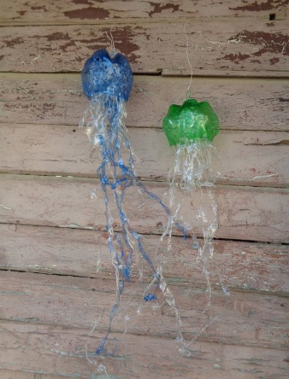
Giant Jellyfish

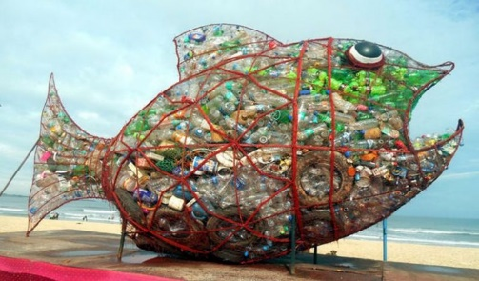
Wire/vine structure stuffed with plastic

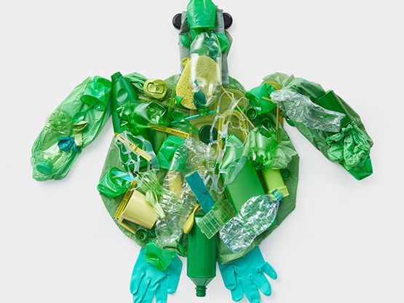
Turtle Plastic Collage

It may not be completed this afternoon, but when your masterpiece is complete, please send me a picture – aharrison@cooperperry.staffs.sch.uk I look forward to seeing your creations!

